**Front-end**

The front-end of the website is built by HTML and CSS. We aim to build a web app that can be played on many devices: Desktop, Laptop, Tablet, Phones, for that reason, CSS is a must to build a responsive web page. To be more specific we set up CSS according to devices width:

Max width > 1200px for Desktops,

Max width < 1200px for Laptops,

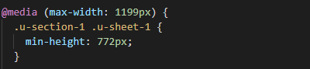

Max width < 992px for Tablets,

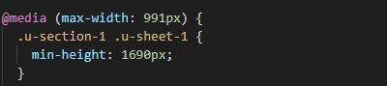

Max width < 768px for Landscape Phones,

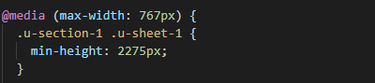

Max width < 576px for Portrait Phones,

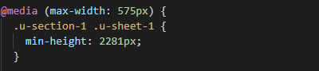

### Main page

#### UI Layout

We control the layout of the main page by ultilising blocks (<section> and <div> tags).

The main page has 3 layers: the default layer, the flags layer, which will be toggled when you click the flags icon (254 flags, scrollable) and the profile layer which will be toggled when you click the button on the upper right corner of the page, the images below will demonstrate our idea of the layout but not our final version:

The default:

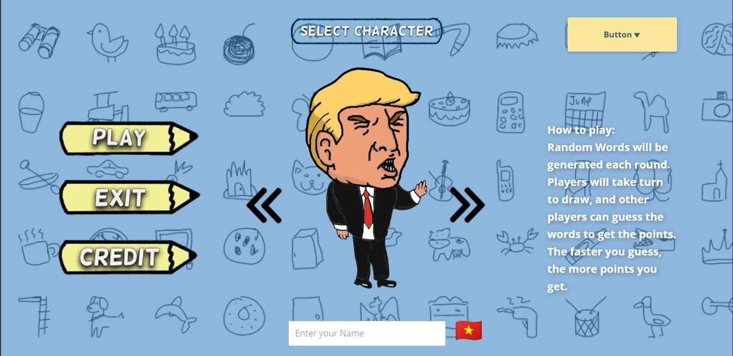

The ‘flags’ layer:

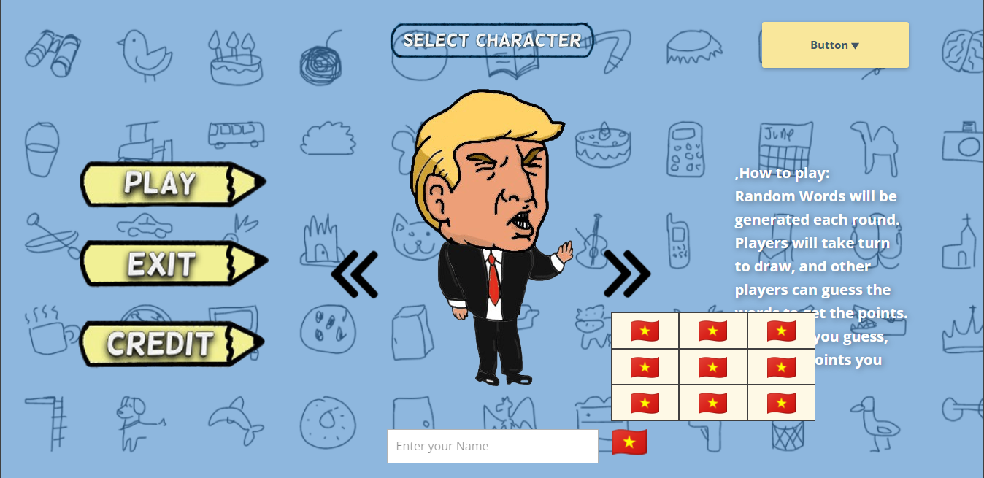

And the ‘Profile’ Layer:

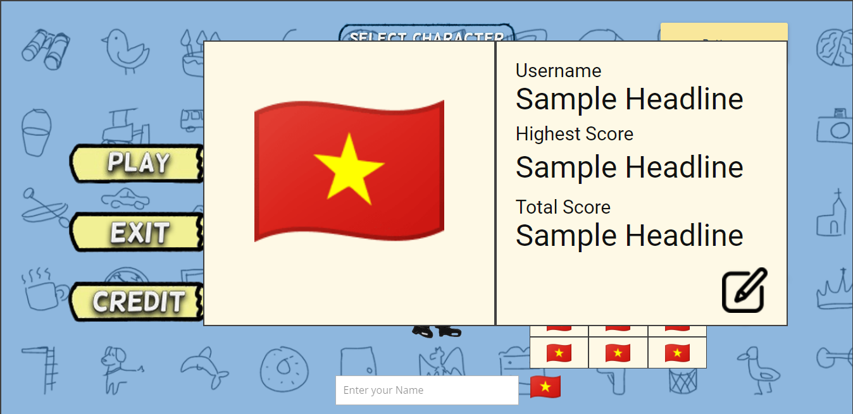

#### Functionalities

The main page functionalities can be summarized as customizations. In the main page you can select character (avatar) using the left-right arrows. You can also select your national flag and your name if your logged in as a guest. In case you logged in, your flag and name will be initialized based on your account info.

The default info would be Character: Trump, Flag: Viet Nam and Name: blank, in case the name is left blank, the web page will generate a random name.

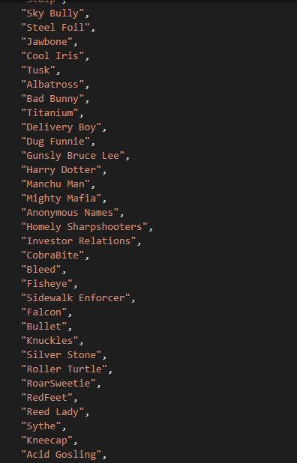

The three buttons on the left: the play button will send your character info to the firebase database, this info will be used during the playing process. Note that the firebase database will be deleted when the game ends, it’s different from the player account database which is static. The exit button will redirect you to google.com, at first, we plan to close the tab when you click the button but that functionality is not supported by modern browsers anymore. The Credit button will just redirect you to a page which shows our brief info.

#### Page Content

All of the Images, Drawings and many of the button icons are designed by Gia Linh, and they looks cool !

There are 10 characters to choose from.

#### Data Process

The data sent to firebase will be in JSON format, luckily google firebase has some very powerful libraries to support the data manipulation.

Import libraries by using module type Javascript:



After connect to Firebase we can then add player info to the database.

The push() function is used to generate random id for each player on the database.

After pushing player info to the database, we get the id list to decide which player is the first player to enter the room, the first player will be the one who set up game rules and start the game in the waiting room.

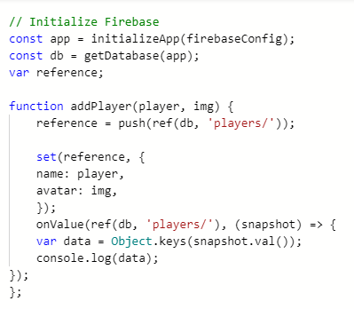

### Waiting room

#### UI Layout

The waiting room has one default layer. In the page there are two main sections: the from on the left and the grid layout on the right. As shown in the image below, our game only supports 9 players playing at the same room. The image below is not our final version:

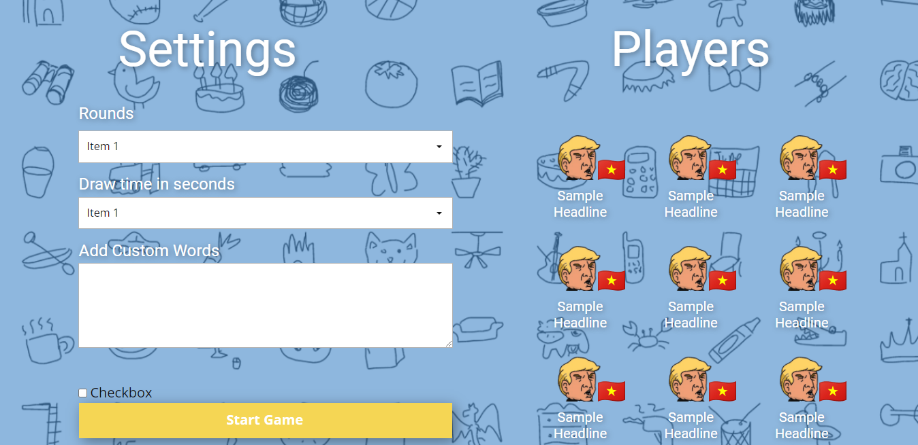

#### Functionalities

The grid layout show players info in format (avatar + flag) + playername.

The form on the right is used to set up the game rules, the first player can set up the number of play rounds, time limit each round and he/she can also add custom words (optional) to the game dictionary, these words are not surely used in the game. The checkbox is used to toggled Exclusive use of custom words which means the custom words will definitely be used in the game.

The default settings are: Rounds: 3, Draw time: 60 seconds, Custom Words: blank, Check box (toggle): unchecked (off).

Only the first player can set up the game rules, the form is disabled for other players.

All players will be redirected to the game room when the first player hits ‘start’.

#### Data Process

Player info is retrieved from firebase database when the page loads, and the game rules are also sent to the database in JSON format when the first player start the game.

